High Level Design - UML
Version No:1
Date: 27-02-11

Project Name: Webstore Application
Project Code:

< Address>

Copyright Notice
The contents of this document are proprietary to <HCL technologies LTD>. And shall not be disclosed, disseminated, copied, or used except for purposes expressly authorized in writing by < HCL technologies LTD >.

Revision History

Version No | Date | Prepared by / Modified by | Significant Changes
1 | 25-Feb-2011 | Sudha | Overview, System Environment
2 | 28-Feb-2011 | Sudha | DataflowDiagram
3 | 01-Mar-2011 | Deepika | FlowChart,Design Overview
4 | 04-Mar-2011 | Sudha | Design Descriptions, and Design Considerations

Glossary
Abbreviation | Description
DB | Data Base
HLD | High level Design

Table of Contents
1 Overview 5
1.1 Purpose 6
1.2 Scope 6
1.3 Brief description of product 6
2 System Environment 7
2.1 System Inputs 7
2.2 System Outputs 7
3 Hardware and Software Platforms 8
3.1 Hardware 8
3.2 Software 8
4 Process Model 9
4.1 Data / Signal Flow Diagram 9
4.2 Flow chart 10
5 Prototype 12
5.1 Scope 12
5.2 Objective 12
5.3 Observations 12
5.4 Conclusion 12
5.5 Entity, attribute and their Relationships 12
5.6 Data Sizing and Performance 12
5.7 Processing Specification 12
5.8 Exception, Signal and Error Handling 12
6 Design Overview 13
6.1 Existing Architecture 14
6.1.1 Network Diagram/Architecture diagram 14
6.1.2 Technical Overview 14
6.2 Proposed Architecture 15
6.2.1 Network Diagram/Architecture diagram 15
6.2.2 Technical Overview 15
7 Design Description 15
7.1 Design Methods Analysis 15
7.2 Basis on which the design is arrived 16
7.3 Design Constraints 16
7.4 Quality attributes of the design 16
8 Alternate Design Methods Considered 17
9 Construction Strategy 17
10 Behavioral Description 18
10.1 State Chart 18
10.1.1 State 18
10.1.2 Transitions 18
10.1.3 Events 18
11 Design Considerations 18
12 Issues and Risks 19
13 Cross References with Software Requirement Specification 19
14 References 19

1.Overview
This document describes the online shopping portal functionality. With this portal user can navigate through a web-site where a new user can register with the web-site and a registered user can do shopping online.
If the user is already registered then he/she can log in to the website, can view his/her profile, can search for products/items ordered by different categories and catalogs, he/she can place the selected items/products in the cart and the user can make an order by providing his details like address to where the ordered items/products to be shipped and he/she can make payment using his credit/debit card.

This application is built using J2EE Technology which makes use of the following technologies.
(i) Struts – As controller
(ii) Hibernate – For managing the persistence
(iii) JTA – To perform transactions
(iv) JNDI – To connect to the database
The backend (database) used is MySQL. Database is present separately in application folder App_data. The project also has a separate database layer class in App_Code in which all the code for opening a connection to the database, inserting the data into the database and returning the data from the database either as a data-set or as a data-table is written which reduces the redundancy of code.

1.1 Purpose
This document describes the online shopping portal functionality. With this portal user can navigate through a web-site where a user can do shopping online.

1.2 Scope
Anyone who is interested in understanding the “Practise Labs Online Webstore Application” internal design and enhancements that can be done should read this document.
This product is used in all HCL Technologies (India) training centers. This product is intentionally bugged, where trainees will debug this product in their practice labs at later stage.

1.3 Brief description of product
Car Audio & Video, TV & Video, Home Theater & Audio, MP3 & Portable, Cameras & Camcorders are the products available in the online Web Store portal where the customers can select the products for buying. The products which are available in the shopping portal are independent and totally self contained.

2 System Environment

2.1 System Inputs
The data-items which are required by the system to produce the output shall include the following things:-

- All the details of users ( if user is a new/unregistered user)
- A valid Username
- A valid Password
- Name of the product (in search field)
- “Click product link” (Selecting the product from the list).
- Triggering “Add to Cart” (Adding selected product to the cart).
- Triggering “Update” (Updating the cart by giving quantity).
- Triggering “Remove” (Removing the product from the cart).
- Enter the order details (card details, shipping address details)

2.2 System Outputs
The data-items which are likely to be produced as outputs from this product shall include the following:-

- Registering a new user.
- Validating Username and password.
- Showing Logged-in user’s profile.
- Showing product list.
- Adding the selected product to the cart.
- Updating the selected product in the cart.
- Removing the selected product in the cart.
- Entering order details into DB.
- Showing the ordered details .

3 Hardware and Software Platforms

3.1 Hardware
The system should work on most of the home desktop and laptop computers. This is the hardware that this application requires. The product can be run on any system irrespective of the OS in which it was running on. The only requirement was the system should have a browser installed on it.

3.2 Software
The system is designed to run on any version and any type of browser preferably go for Firefox 3 and Internet Explorer 7. The system should have the following soft-wares running on it:
Java Development Kit( jdk 1.6)
Eclipse 7.0 or Netbeans 6.9
Apache Tomcat Server 7.0 (or other versions)
MySql Database Server

4 Process Model

4.1 Data / Signal Flow Diagram
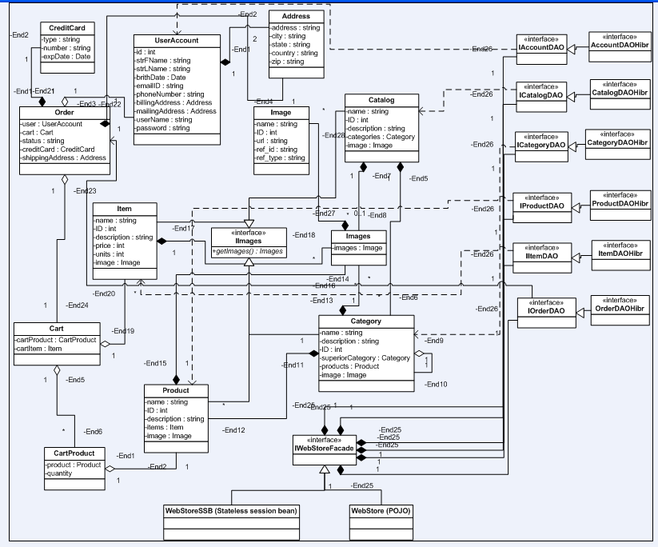

4.2 Flow chart
Start
Click on Home

B
Select a Catalog

Select a Category

Select a Product

If
an Item
exist

Yes
Add necessary Item to the cart

No
Add selected Product to the cart

Update the
cart
Remove from the cart

If already signed user
If Registered User?

YES NO
Sign-In

NO
YES
A
Register

A

Order
Stop
B
Shipping details
Sign-Out

Prototype

Scope
NA

Objective
NA

5.3 Observations
NA

5.4 Conclusion
NA

5.5 Entity, attribute and their Relationships
NA

5.6 Data Sizing and Performance
NA

5.7 Processing Specification
NA

5.8 Exception, Signal and Error Handling
NA

6 Design Overview

User
Unregistered Customer
Registered Customer

Registration
Sign-In
Browse/Search the Products/Items for shopping
Add to the Cart
Update the Cart
Remove from the Cart
Order
Shipping Details

Payment Details

Sign-Out

Existing Architecture

Network Diagram/Architecture diagram
RDBMS
Supplier
OPC
E-mail
JMS
JMS
http/
https
User

6.1.2 Technical Overview
01. 3 tier(s):
- Enterprise
- Web
- Client
02. Persistence managed by:
- Hibernate
03. Usage of the following technologies:
- JMS
- JTA
- JavaMail
- Struts
- Hibernate
- JNDI
- Spring 2.0
04. Usage of J2EE design patterns
05. JUnit for testing
06. Authentication using https
07. RDBMS Independent
08. Generic shopping solution for all uses.
09. J2EE projects:
- WebStore

Proposed Architecture

Network Diagram/Architecture diagram
RDBMS
Supplier
OPC
E-mail
JMS
JMS
http/
https
User

Technical Overview
NA

Design Description

7.1 Design Methods Analysis
The design methodology used here is a “Top-Down design” approach. It is the set of procedures that we followed from the beginning to the completion of the software development process.
Top-down design is chosen as it directs the designers to start with a top-level description of a system and then refine this view step-by-step. With each refinement, the system is decomposed into lower-level and smaller modules. Top-down decomposition requires identifying the major higher-level system requirements and functions, and then breaking them down in successive steps until function-specific modules can be designed. Thus, top-down design is a level-oriented design approach.

Basis on which the design is arrived
The nature of choosing this methodology is dependent on a number of factors, including the:
  - software development environment
  - the organization's practices
  - the nature or type of the software being developed
  - the requirements of the users
  - the qualification and training of the software development team
  - the available hardware and software resources
  - the availability of existing design modules and even
  - the budget and the time schedule.

Design Constraints
The design constraints which are most likely to be considered as best following practices are:
- Naming conventions and packaging of classes should be done properly

Quality attributes of the design
The key quality attributes which are to be considered while designing this product are:
- Availability
- Security
- Reliability
- Operability
- Accuracy.
- Availability
Once hosted onto the World Wide Web the application will be available for 24X7 hours or may change depending upon the vendor’s requirements
- Security
The application provides the user with a high-level of security. The user profile details will be shared only with the other users registered with the portal. No anonymous user can have access to the registered users profile information. Secure information like users credentials (username and password) are not shared with anyone other than administrator him-self.
There are no specific strategies chosen to achieve the above key / crucial quality attributes.
- Reliability
The Web server of the portal is accessible to all kind of customers.
- Operability
There are links provided on the right corner throughout the site as part of the navigation system to give customers constant access to all the web pages available and allow the user move easily through the product options.
- Accuracy
The images, descriptions and prices given in the online portal accurately resemble the original items/products.

8 Alternate Design Methods Considered
The design methods which are listed above in the design overview section are followed through-out the development of the product. No other alternate design methods are considered.

9 Construction Strategy
Since the product is developed from the scratch, there are no such modules / functions identified which will be re-used from the database or which need some external components. So no such verification and validation requirements of items were found.
No | Module / Function | Buy / Re-use | Verification / Validation | Remarks
NA | NA | NA | NA | NA

Behavioral Description

10.1 State Chart
<This is an option section. This section describes the module state table, if any. All the states, their transitions and associated events may be detailed here>

State

Transitions

10.1.3 Events

11 Design Considerations
There are several design considerations which are to be taken into account while developing this product. They are:
What are the goals of the web-site?
Who are the target audience?
What do you want your site to look like?
Where is the site to be hosted?
What are the success criteria for your site?
You will have to design web-pages that can be displayed by many different browsers. Common browsers include Microsoft Internet Explorer, Mozilla Firefox, Apple Safari and Google Chrome.
You should test your web-pages in as many browsers and different operating systems as possible during the development process to ensure that they will display properly
You should also ensure that your web-pages work in previous versions of the browsers, as some of your audience may not have updated their software.

12 Issues and Risks
Usability problems can create the issues and may cause risks for the user. Some of the usability problems which are experienced by audiences of the web sites are listed below:
- Redundancy: Information that is needlessly repeated during navigation
- .Inconsistency: Would result to distrust by users of the site because the information is inconsistent and unreliable.
- Incompleteness: As a result of stale or a broken link, the users are not able to find the information they need.
- Lack of clearly defined mission statement or project scope analysis.
- .Lack of clearly identified target audience

13 Cross References with Software Requirement Specification
This section will be described in detailed in Requirement Traceability matrix where each module’s cross-reference with SRS will be shown much clearly. This is explained in a tabular form showing the mapping of each module with SRS

14 References
1. CF_PL_J2EE_WebStoreProject_FunctionalTestCases.xlsx document.
2. Guidance from real-time online shopping Website

